Translator Guideline (Part I): Main Text
Rule 1: Provide dates for people and reigns 1
Rule 2: Provide traditional Chinese characters for people and places. 3
Rule 3: Citing the Title of Primary Sources
3.1. Chinese Texts 4
3.2. Japanese Text 5
3.3. Tibetan Texts 5
Rule 4: Citing Chinese Passages 6
Rule 5: Translating Terminologies 7
6. Miscellaneous Rules 8

Translator Guideline (Part II): Bibliography and Footnotes

1. Abbreviation 10
2. Primary sources 10
2.1. Indian Texts Referenced to the Taisho Canon 10
2.2. Chinese Texts Referenced to Taisho 10
2.3. Chinese Texts Referenced to Modern Publications 11
2.4. Tibetan Texts 11
3. Secondary Sources I: East Asian Languages 12
3.1. Journal Article 12
3.2. Book 12
3.3. Book Chapter 12
3.4. Japanese Sources 13
3.5. Re-published Source 15
4. Secondary Sources II: Western Languages 16
4.1. Book 16
4.2. Article in an Edited Work 16
4.3. Journal Article 16
4.4. Dissertation 16
4.5. Photocopied material 16

Translator Guideline (Part I): Main Text

Rule 1:

Provide dates for people and reigns (only their first appearance)
E.g., Fazang’s 法藏 (643-712) commentary is considered the most definitive commentary on the Huayan jing.
E.g., During the reign of Zhenguan 貞觀 (598-649)…
E.g., In Zhenguan 貞觀 3.9.20 (October 11, 629)
[Note]
1. Use this succinct format to express the 20th of the 9th lunar month of the 3rd year of the Zhenguan reign.
2. Provide the date in the Western calendar. Use this converter: https://sinocal.sinica.edu.tw/.
E.g., (?-678)
[Note] When the date of birth or death is unknown.
E.g., Zhiqiao支喬 (d.u.)
[Note] Use (d.u.) when both dates are unknown.
E.g., Yuanzhao 圓照 (fl. 8th c.)
[Note] fl. is the short for ‘flourished’, meaning his active years.
E.g., (476+-521+)
[Note] Born as early as 476 and died as early as 521. Consult Buddhist Studies Person Authority Databases (https://authority.dila.edu.tw/person/).

Rule 2:

Provide traditional Chinese characters for East Asian people and place.

(This rule applies to both historical figures and contemporary scholars)

E.g., Zhu Lishuang 朱麗雙, in her study of the Khotanese texts, pointed out that
E.g., The origin of the Ximing Monastery 西明寺 is related to …..
[Note] Translate si as monastery, not temple:
E.g., Shoshin Kuwayama 桑山正進 analyzed the causes underlying the decline of Gandhāra.
[Note] For Chinese and Japanese names, make sure the last name precedes the first name. Google usually inverts the order, so be careful.
E.g., Buddhabhadra (Fotuobatuoluo 佛陀跋陀羅; 359-429).
[Note] For an Indic name, first provide Sanskrit name, then pinyin and Chinese character in the parenthesis, followed by dates.
E.g., 釋彥琮: Yanzong 彥琮 (557-610)
[Note]
1. No need to transcribe the monastic title shi 釋.
2. Do not separate a monastic name into first and last name. (Yanzong > Yan Zong; Xuanzang > Xuan Zang).

Rule 3:

Citing the Title of Primary Sources

3.1. Chinese Texts

Example 1

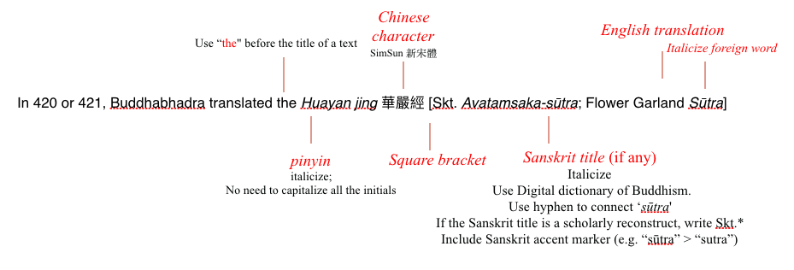
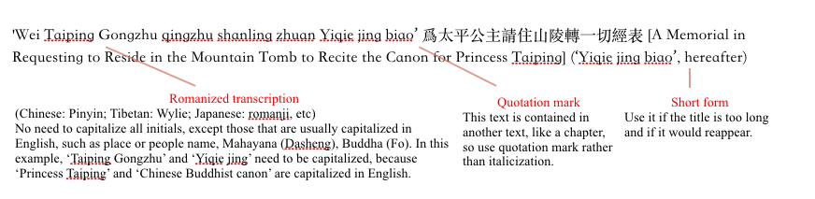
Example 2

Example 3
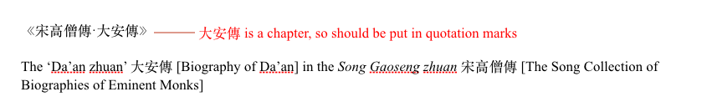
3.2. Japanese Text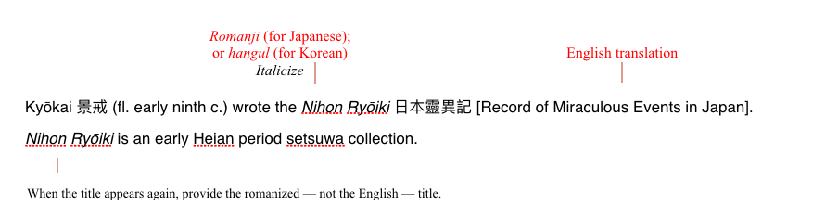
[Note]
In all the cases above, when the title is mentioned again, provide the pinyin (or romanji or hangul) rather than the English translation.

3.3. Tibetan Texts 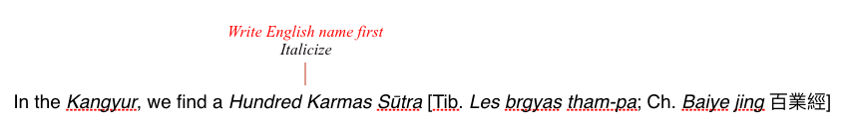
[Note]
When a Tibetan title reappears in the text, you have the option of using the English translation (rather than the Tibetan transcription), which may be easier for the readers to follow, given that the knowledge of Tibetan is less comm

Rule 4:

Citing Chinese Passages

Example 1 (Long Passage)

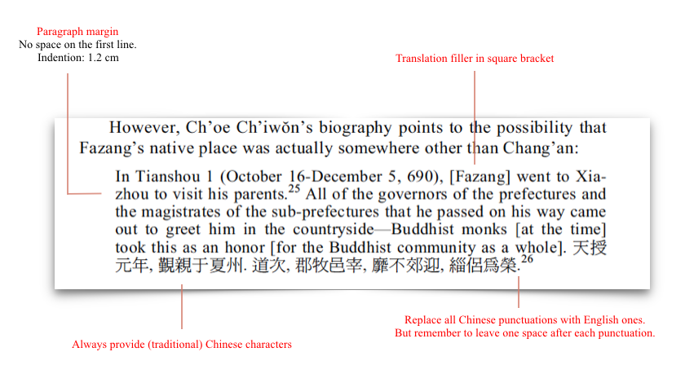

Example 2 (Short Passage)

Zhisheng noted that ‘It has 18000 gāthās … this treatise has not been translated’ 有一萬八千頌…其論未譯.

[Note] If the original passage is only one short sentence, there is no need to open a new paragraph.

Rule 5:

Translating Terminologies

5.1. Provide a rough English translation before giving the original term in the parenthesis. When this term re-occurs, it suffices to provide the English translation.

Example 1

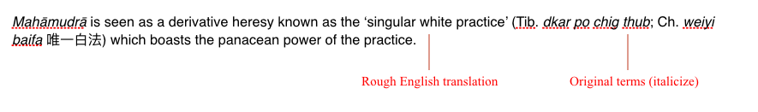
Example 2

The Nanshan Vinaya Tradition (Nanshan lüzong 南山律宗)

Example 3

Ox-Horn Mountain (Niujiao shan 牛角山) is a sacred site that is commonly featured in Buddhist sūtras. Scholars generally identify the Ox-Horn Mountain as Mount Kohmārī.

[Note] In the two examples above, both terms is not italicized, because they are the name of a place and a tradition, not a technical term.

5.2. For certain terms, it is possible to always use pinyin rather than the English translation. This approach is especially called for when a term is at the center of an analysis. For instance, Liu Yi’s book analyses the complex connotations of the mofa doctrine, and the term mofa repeats at a high frequency in the book. In this case, it is better to just use pinyin.
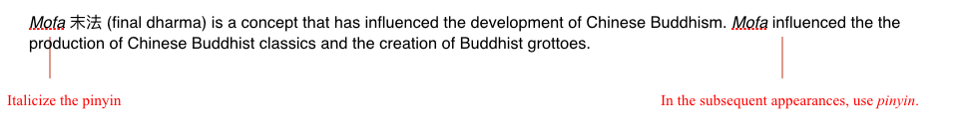

[Note] But be mindful not to use too much pinyin in your translation, for this may obstruct the flow of the text. Use this approach only when a term is central to the author’s analysis, such as the example above, or when a term is being talked about as a word: e.g., There are controversies as to the exact Sanskrit antecedent for the word huayan (Flower Garland).

6. Miscellaneous

1. Capitalize the first letter of a direct quote when the quoted material is a complete sentence.

E.g., All sūtras start with “Thus I have heard...”.

2. Italicize Asian spellings, rather than put it in the quotation mark.
E.g., The original meaning of the word mo 末 is ‘the top of a tree’.
(Better than: The original meaning of the word ‘mo’ 末).

3. When italicizing a foreign word, the plural “s” should not be italicized.
E.g. sūtras > sūtras.

4. Use the single quotation mark (‘’) rather than the double one (“”).

5. Translate 卷 as juan(s), fascicle(s), but not scroll(s) or volume(s).

6. Always check with your fellow translators to be consistent with their translation, especially when it comes to terminologies and titles.

7. Turn off the automatic spelling corrector when working on the bibliography and footnotes where many pinyin may be ‘corrected’ incorrectly.

8. When uncertain about your translation, leave a comment (select ‘insert’ – ‘comment’) so that the author could later verify your translation or answer your question.

9. In a title, not every initial need to be capitalized, including articles, conjunctions, and prepositions. E.g., The Old Man and the Sea. Exception: the first word in the subtitle needs to be capitalized. E.g., The title: The subtitle.

Translator Guideline (Part II): Bibliography and Footnotes

Break the bibliography in three sections:

- Abbreviations (if applicable)
- Primary Sources
- Secondary Sources

1. Abbreviation
See the examples in the bibliography section in Jinhua Chen’s book on Fazang.

2. Primary sources

2.1. Indian Texts Referenced to the Taisho Canon
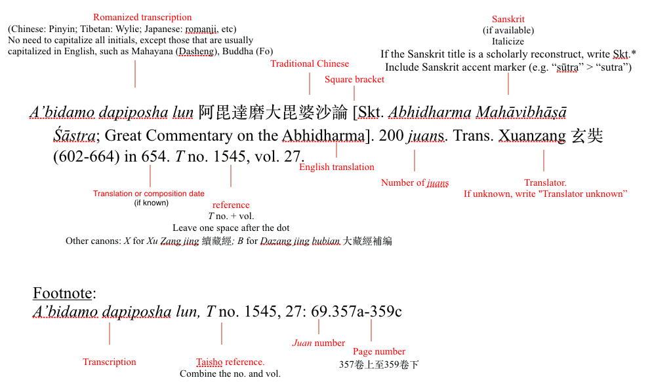

2.2. Chinese Texts Referenced to Taisho

Bianzheng lun 辯正論 [Treatise on Distinguishing the True]. 8 juans. By Falin 法琳 (572-640). T no. 2110, vol. 52.

Footnote:
Bianzheng lun, T no. 1545, 27.

2.3. Chinese Texts Referenced to Modern Publications

Chu Sanzang jiji 出三藏記集 [Collected Records concerning the Tripitaka]. 15 juans. By Sengyou 僧祐 (445-518). T no. 2145, vol. 55. Reference made to Chu Sanzang jiji 出三藏記集, edited by Su Jinren 蘇晉仁 and Xiao Lianzi 蕭錬子. Beijing: Zhonghua shuju 中華書局, 1995.

[Note]
No need to translate the publisher’s name.

2.4. Tibetan Texts

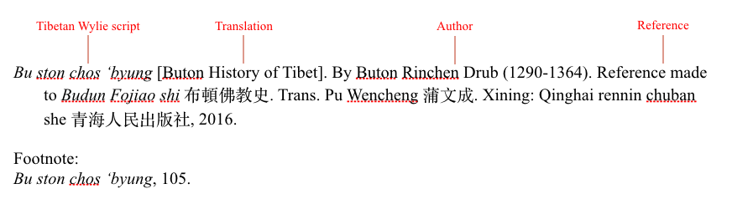

3. Secondary Sources I: East Asian Languages

3.1. Journal Article
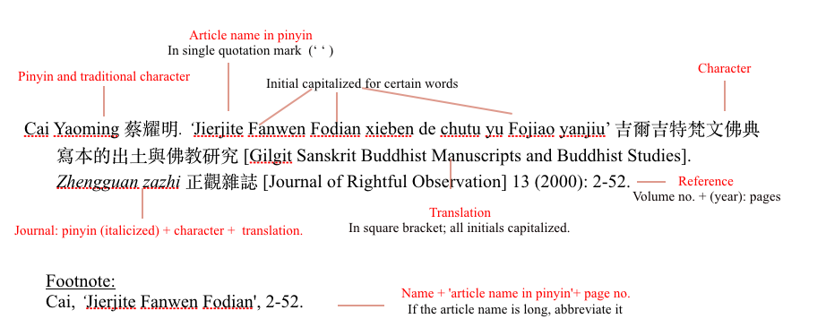

3.2. Book
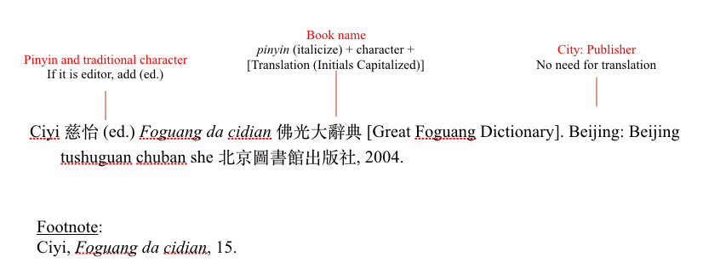

3.3. Book Chapter

Example 1 (In a book by the same author)
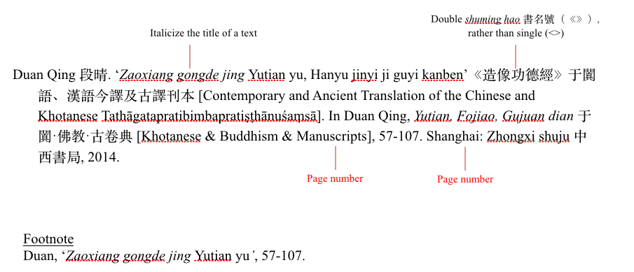

Example 2 (In an edited work)

Zhu Lishuang 朱麗雙, “Yutian guo shouji suozai zaoqi Yutian wangtong tongji” 《于闐國授記》所載早期于闐王統硏究 [Early Royal Lineage of Khotan as Recorded in the Prophecy of the Li Country]. In Tansuo Xiyu wenming 探索西域文明 [Explore the Civilization of the Western Regions], edited by Meng Xianshi 孟憲實 and Zhu Yuqi 朱玉麒, 199-213. Shanghai: Zhongxi shuju 中西書局, 2017.

Footnote:
Zhu, ‘Yutian guo shouji’, 200 (if quoted from a specific page); or Zhu, ‘Yutian guo shouji’, 199-213 (if referred to the whole article).

3.4. Japanese Sources

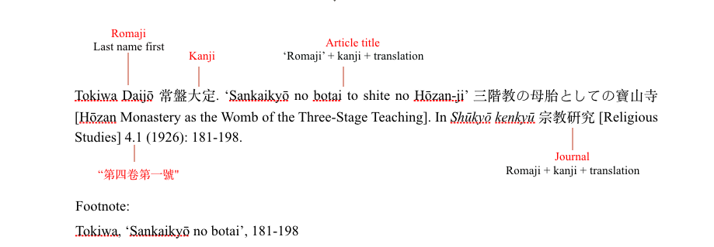
[Notes on Japanese Sources]

1. Google typically displays the first and last name of a Japanese scholar in the reverse order, but make sure to put the last name first, as in a Chinese name.

2. Even if you do not know Japanese, you could still translate the Japanese sources by using this database (https://www.inbuds.net/) which lists the hirakana title of the source. Pass this romanji title through a hirakana-to-kanji converter (https://j-talk.com/convert).

3. In any case, it is best to review the transliteration, as some kanjis correspond to multiple romajis. For instance, 寺 could be transliterated as either tera or ji, but when it is part of a monastery’s name, it should be ji.

4. Not all kanji can be converted by using the online converter, especially when it comes to the name of people and place, and technical terms. You need to look up the romaji for these un-transcribed kanji. You may find the Jisho Dictionary and the Digital Dictionary of Buddhism (DDB) helpful. For instance, in the example below, 靈裕 cannot by converted by using the online converter, but its romanji can be found on DDB.
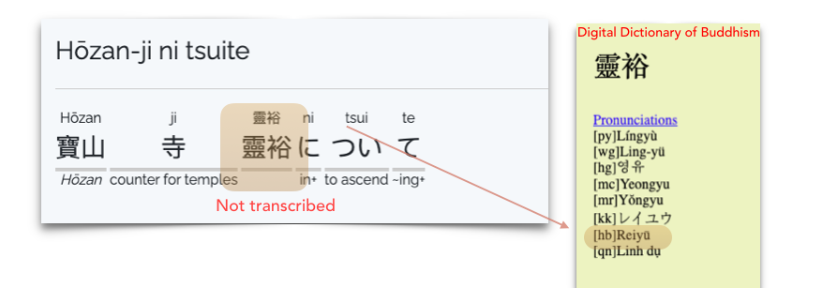

3.5. Re-published Source

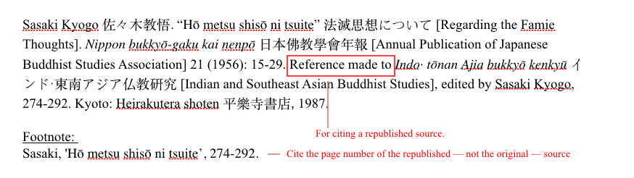

4. Secondary Sources II: Western Languages

4.1. Book
Marx, Karl, and Frederick Engels. The German Ideology. London: Lawrence and Wishart, 1977.

4.2. Article in an Edited Work
Feith, H., and A. Smith. ‘Indonesia’. In Southeast Asia: Documents of Political Development and Change, edited by R.M. Smith, 99–110. Ithaca: Cornell University Press, 1970.

4.3. Journal Article
Mendelson, E.M. ‘A Messianic Buddhist Association in Upper Burma’. Bulletin of the School of Oriental and African Studies 24.1 (1961): 560–80.

4.4. Dissertation
Puru Shotam, Nirmala. The Social Negotiation of Language in the Singaporean Everyday Life World. Ph.D. dissertation, Department of Sociology, National University of Singapore, 1987.

4.5. Photocopied material
Moore, Philip S. ‘Academic Development: University of Notre Dame: Past, Present, and Future’. Mimeographed. Notre Dame, IN: University of Notre Dame, 1960.

